- \Operation\Monitoring, carton code\Monitoring, carton code
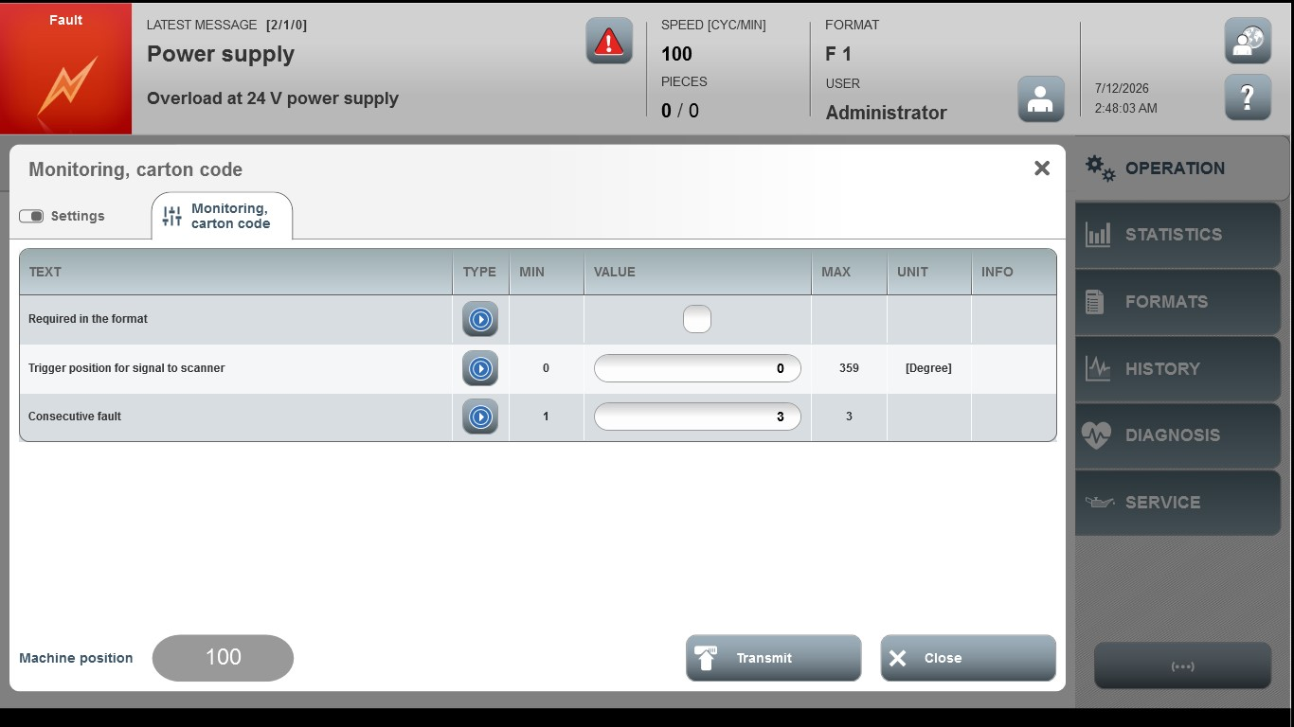

Acceptance criterion | Limits | Pass / Fail: Dev-No. | Date | Initials
Screen matches screenshot | N / A
Trigger position for signal to scanner | 0…359
Consecutive fault | 1 … 3

